System Health Monitor Phase 3
System Health Monitor Phase 3 1
What’s New 2
Instrumentation Collector Server 2
Summary Instrumentors 3
Instrumentor Status Display 3
New Processes in Process Watcher 4
CAS Monitor Screen 4
New Alias Name Maintenance Screen 4
Comma Formatted numbers in System Health Monitor Table 7

What’s New
- The Instrumentation Collector Server (ICS) is a new process for SBT that collects, aggregates and analyzes instrumentation data. The ICS watches all instrumentation data published on the Instrumentation Event Channel, calculates aggregates and publishes summary information for the System Health Monitor (SHM) GUI to use. This offloads a great deal of processing from the SHM and allows the GUI to display summary data for all processes.
- Filtering was added to the SHM CAS Monitor screen to be able to filter the data to only display a particular Firm or CAS type.
- Data for the SACAS, MDCAS and CFIX were added to display on the System Health Monitor CAS Monitor screen.
- A new screen for Alias Name Maintenance was added to the System Health Monitor.
- Comma formatted numbers in System Health Monitor

Instrumentation Collector Server
With the addition of the Instrumentation Collector Server (ICS), the System Health Monitor will not communicate with the Collector and not the raw event channel for instrumentation data. If the ICS is not running in Master mode, the System Health Monitor GUI will use the instrumentor data from the event channel, like it does now. This determination is made when the GUI comes up. It does not change this dynamically.

Summary Instrumentors
The ICS takes all the instrumentors it receives and publishes summary instrumentors. The instrumentors are summarized by instrumentor type and Orb Name. The summary instrumentors are then published so the GUI can display them. The GUI will display summary instrumentors for all processes that are not subscribed for detail. This allows the GUI to display information at a summary level for all processes. If you subscribe for detail for a process, the summary instrumentors will not display. The name of a summary instrumentors is always <instrumentorType>Summary (ex, QISummary). The only exception is the Heap Instrumentor, which is always published as is.
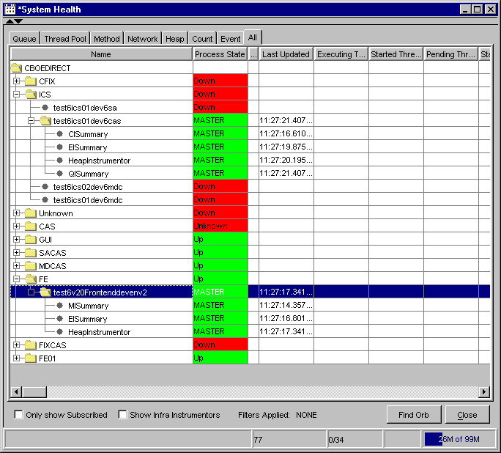

Instrumentor Status Display
The main toolbar for the System Health Monitor now contains a piece in the status bar that identifies the status of the System Health Monitor and Collector.

The first piece of the display identifies how the GUI is attached to instrumentation data. A “CO” means the GUI is getting instrumentors from the ICS. A “EC” means the GUI is getting instrumentors from the Event Channel and is skipping the ICS.

The second piece of the display is the number of instrumentors the GUI has received in the last 11 seconds. This display will color yellow if a period passes where the number of instrumentors received is zero. The display will color red if at least two consecutive periods pass where the number of instrumentors received is zero. If either of these conditions occurs, there is a major issue with the GUI.

The third piece of the display is the ICS status. The process status (Master, Slave, Down) of all the ICS processes is displayed. A tool tip for the process status will display the Orb Name of the ICS displayed.

New Processes in Process Watcher
With the rollout of Phase 3, there will be several new processes in process watcher. The ICS process and all the System Health Monitor GUIs will be added to process watcher.

CAS Monitor Screen
Filters for Firm Name and CAS Type were added to the screen. When a selection is made, the filter is immediately applied.
Added SACAS, MDCAS and CFIX to display on the screen.
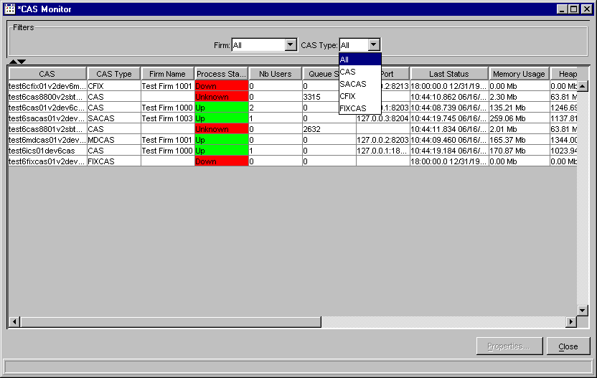

New Alias Name Maintenance Screen
Added a new screen for the maintenance of Orbname Alias. The screen allows the user to view and modify all processes in the system in one easy to use screen. A single row can be edited, or the cluster and sub-cluster can be changed on multiple rows at once.

The screen can be filtered by the Cluster.
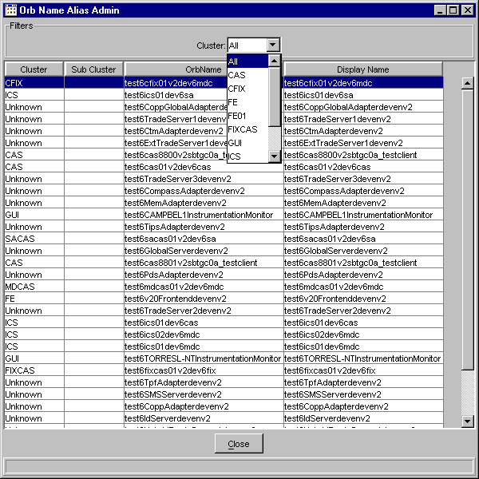

Right-Click menu shows the edit capability for a row or selection of rows. Orb Name Alias Edit will only work on one row at a time. This is the same Edit that is available in all the other screens.

Change Cluster can be performed on a selection of rows.

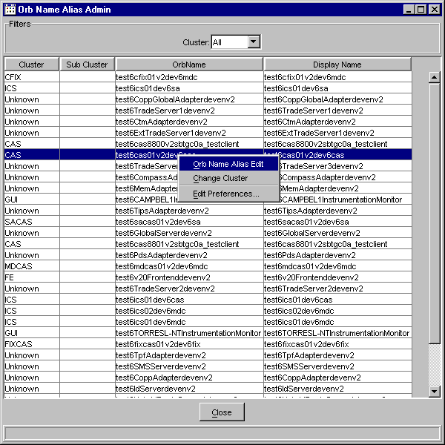

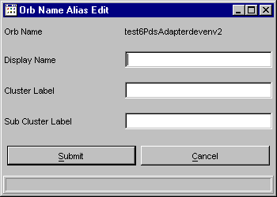

Change Cluster will change the Cluster and Sub-Cluster of all highlighted Rows.
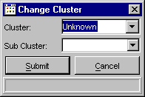

The Cluster and Sub-Cluster drop down boxes are editable and any value can be typed in, or a value from the list chosen.

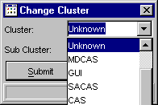

Comma Formatted numbers in System Health Monitor Table
All numbers in the System Health screen now have commas in the appropriate position.
